Google VR SDK for Unity



Virtual Reality is a computerized simulation of natural or imaginary reality. User of VR is fully or partially immersed in the environment. VR is the term used to describe the scene created by any computer program in which the user plays an interactive role within the context of the computer-generated three-dimensional worlds. Virtual reality (VR) is a term that applies to computer-simulated environments that can simulate physical presence in places in the real world, as well as in imaginary worlds.

Head mounted displays are used with headphones and hand controllers to provide a fully immersive experience. With the largest technology companies on planet earth (Facebook, Google, and Microsoft) currently investing billions of dollars into virtual reality companies and startups, the future of virtual reality is set to be a pillar of our everyday lives.

We won’t discuss how virtual reality work. We will just develop a basic virtual reality application using Google Cardboard SDK in Unity3D. If you want to read more detail, I recommend this website: <https://www.realitytechnologies.com/virtual-reality/> or you can get this book: [Learning Virtual Reality by Tony Parisi](https://www.amazon.com/Learning-Virtual-Reality-Experiences-Applications-ebook/dp/B01770MBN4).And I think everyone ,who want to develop virtual reality app using GoogleVR, has to read the article is created by Google in here : <https://developers.google.com/vr/develop/unity/get-started-android> . OK Lets Start

**Set up Your Environment**

* A view and an Android Phone. Of course first you need a hardware. It can be a phone that support Daydream or Cardboard. You can run the app on any Android device has API Level 19 or higher, if you use Cardboard. If you want to use Daydream, check whether your Android device support it or not in [here](https://vr.google.com/daydream/smartphonevr/phones/). You can buy any cardboard view device to run the app. These devices (called glasses) are very cheap. You can buy these devices with payying $3-$5 or if you want good one that is created by Google, pay just $30.
* Unity3D and Google VR SDK. You need version 5.6 of Unity3D or higher. Recommened the lastest version. We will use Unity 2018.2.14. If you don’t have this version or higher, you can download it <https://unity3d.com/get-unity/download>
* Now we need Google VR SDK. (If you already have the SDK skip this step) If you don’t have Google VR SDK and you use Unity version 2017.4 or higher you can install the SDK with using Unity Installer. You can get the installer here. <https://unity3d.com/get-unity/download/archive> Choose your Unity version and select the Unity Installer



* Open the installer and choose components. We are going to make an app on Android platform so we need to Android Build Support,

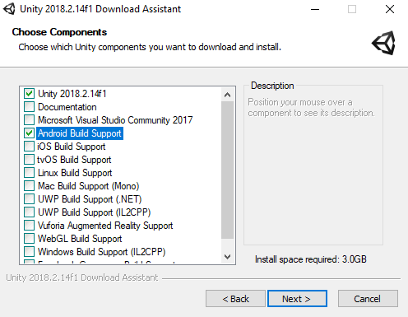

* Now we need Google VR SDK. We can download the lastest GoogleVRForUnity.unitypackagefrom [here](https://github.com/googlevr/gvr-unity-sdk/releases). Download the unity package.
* Now open Unity and import the package the you downloaded. Select Assets > Import Package > Custom Package. Select the package and click import. Or just double click on package. We will build in Android Platform so we need to change the platform. Select File > Build Settings (Ctrl + Shift + B). Select Android and click Switch Platform. You have to installed the Android SDK, Unity Android Support (we downloaded it at the begginning) and JDK (Java Development Kit) to take apk file. And last thing, we have to change some setting at the Player Settings. In the Build Settings (Ctrl + Shift + B) window, click Player Settings.
  + Enable : Player Settings > XR Settings > Virttual Reality Supported
  + Select Cardboard : Player Settings > XR Settings > Virttual Reality SDKs
  + Change Minimum API level : Player Settings > Other Settings > Minimum API Level (API 19 for Cardboard, API 24 for Daydream)
  + Set app’s identifier : Player Settings > Other Settings > Package Name (example: com.zuo.googleVR)

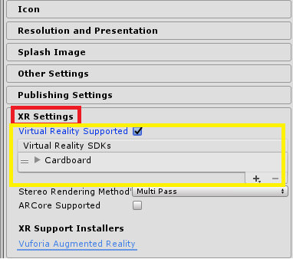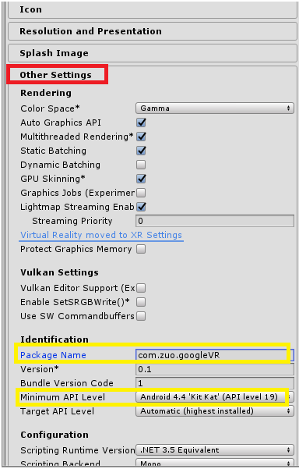

**Let’s Build Our First VR App**

Now we can build our first VR application using demo scene that is comming with imported package. Open the Google VR > Demos > Scenes > Hello VR. You can control the game with pressing Play button. Now building time.Select File > Build (or Build and Run). Set your apk name and click build.

Congratulation you develop your first VR Application. Ohh. Wait a minute. What do you do if you want to build any camera in your own scene for google cardbord? Don’t worry. Just build your own scene as you did before but just change the player settings as we did before (enable virtual reality support and select he cardbord)

